We will refer to the playwright documentation: https://playwright.dev/java/docs/intro
We will do the following:
- Install JDK
- Configure Maven
- Download eclipse
Create a new Maven project.
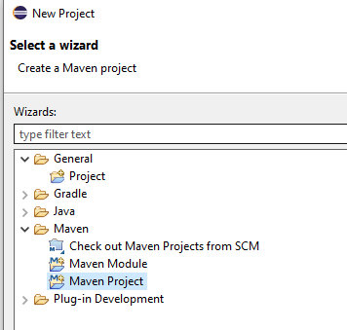
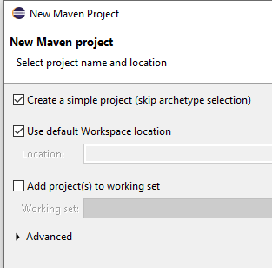
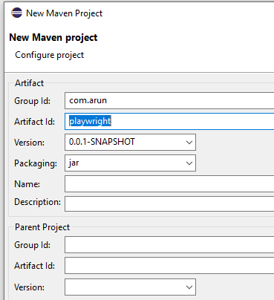
Configure POM.xml
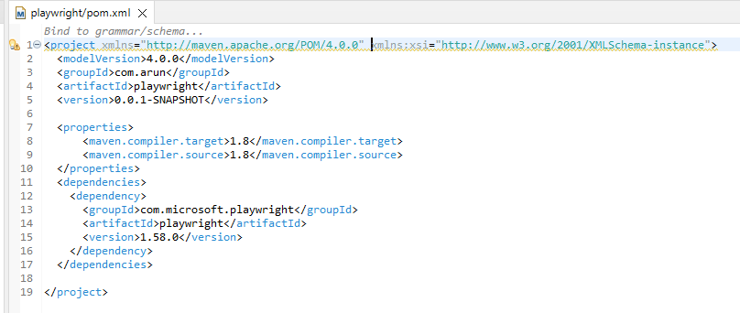
Create a new Java file:
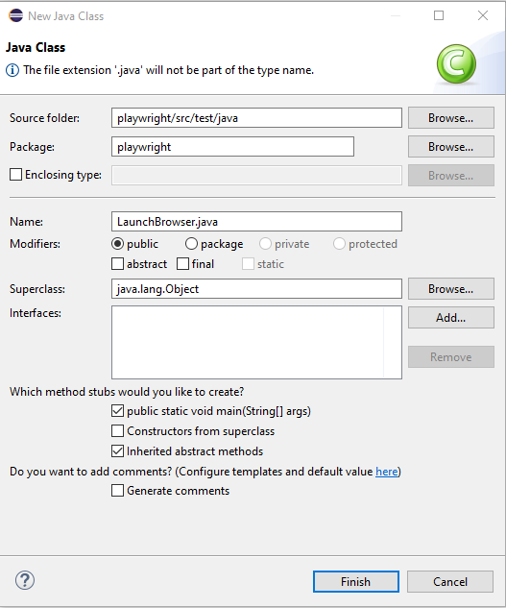
We will create a playwright instance.
Then we create a browser instance using the browser instance.
Then we create a page instance using the browser object.
Using page object we will launch the URL.
Finally we will create the page instance and the playwright instance.
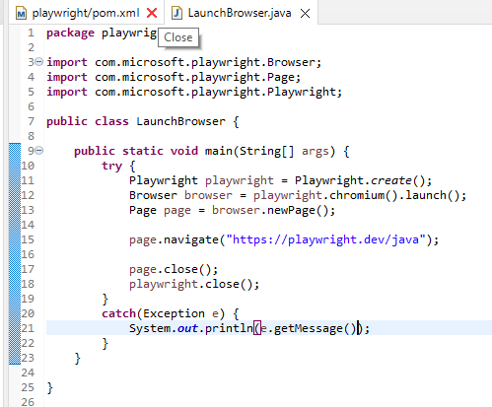
Browser will launch in headless mode.
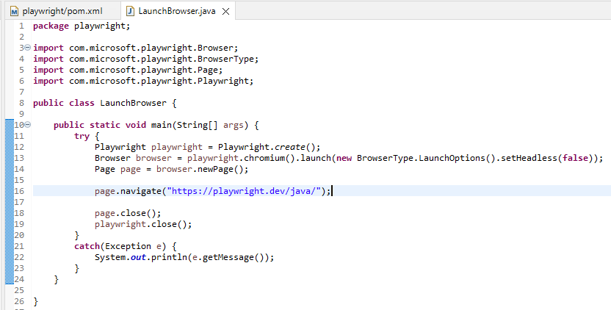

Maximizing Window:
To maximize the window we need the screen size.
https://whatismyviewport.com/#:~:text=Viewport%20size%20refers%20to%20the,operating%20system%2C%20etc.).

Rather than using the browser object we will use the browser context object.
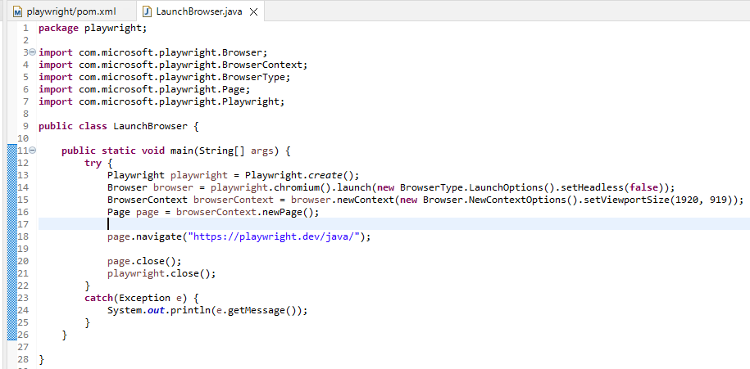
Still we see browser is not getting the full screen.
We need to calculate view port size at the run time. We need to use the dimension class.
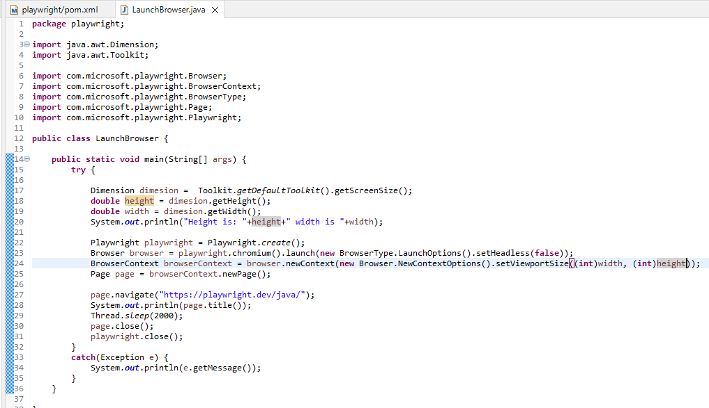
We can also launch execution in edge browser.
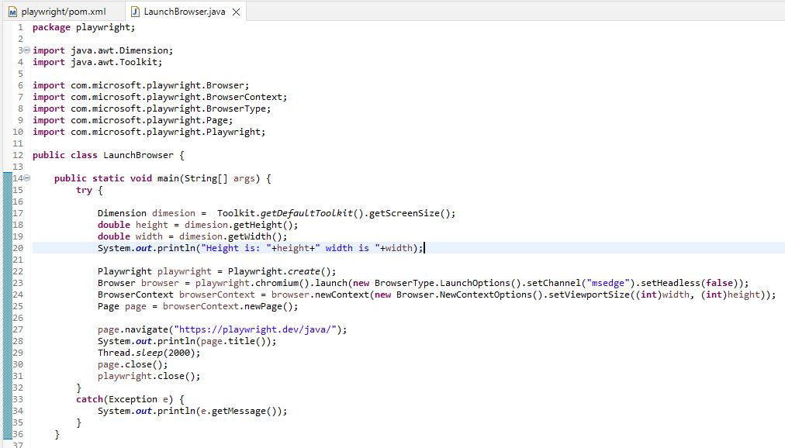
We can also maximize the browser by passing arguments.
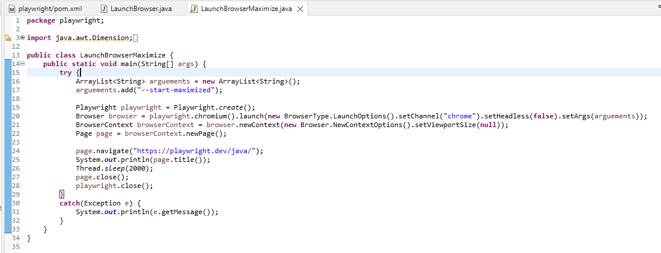
Launching chrome, edge and Firefox browsers:
Chrome:
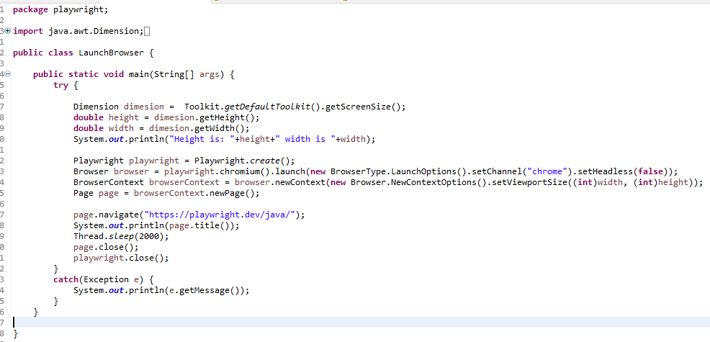
Edge:
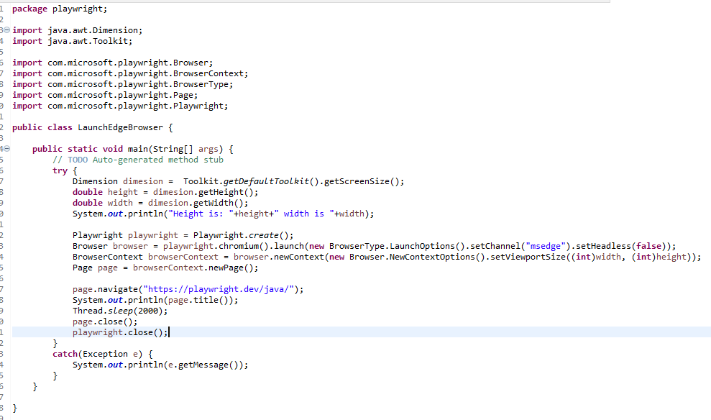
Firefox:
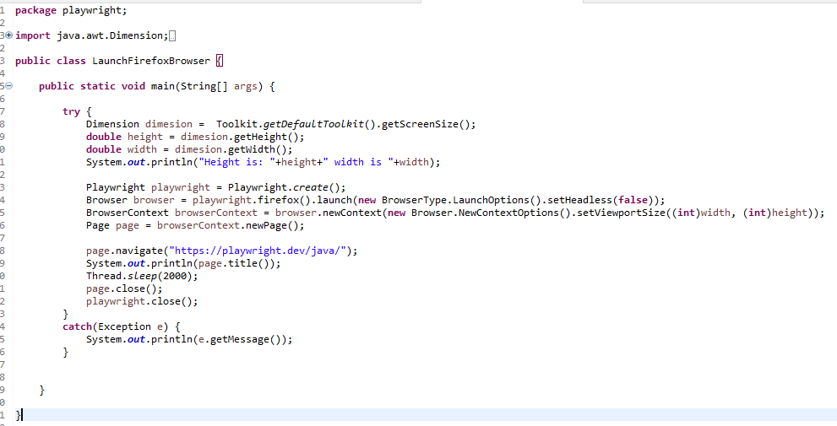

Launching test in Incognito Window:
As of playwright execution was happening in browser in incognito mode or private mode.
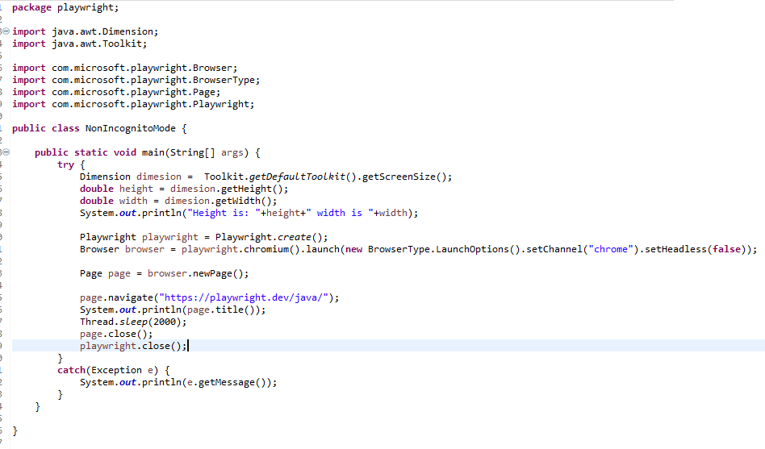
To perform this instead of launch we will use launchPersistentContext. It accepts 2 parameters. In the first parameter we will use the profile path. Instead of LaunchOption we will use LaunchPersistentContextOptions.
These are the 2 changes.
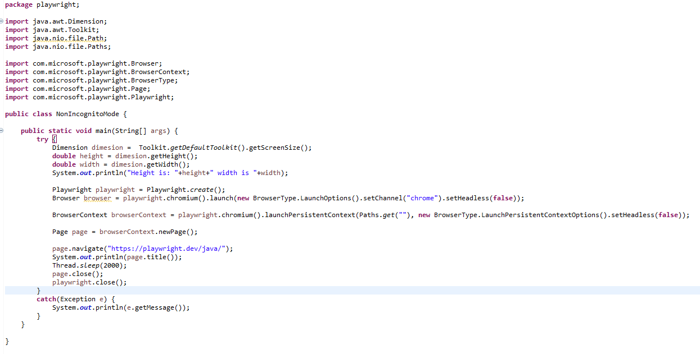
We can also execute by passing the chrome executable path.
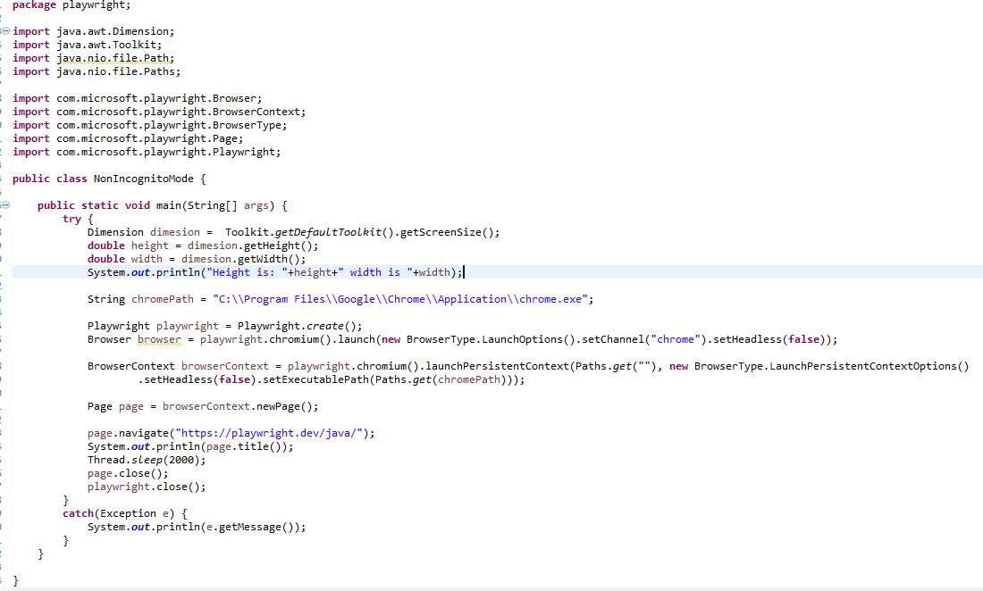
Now suppose we want to launch browser using the default chrome profile.
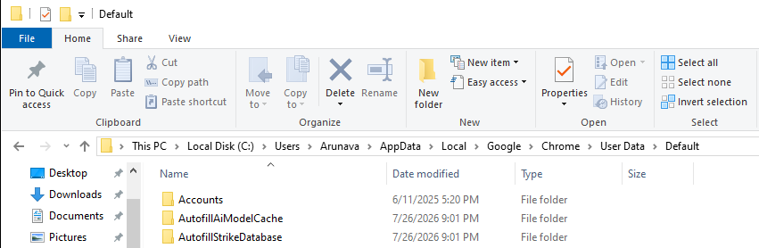
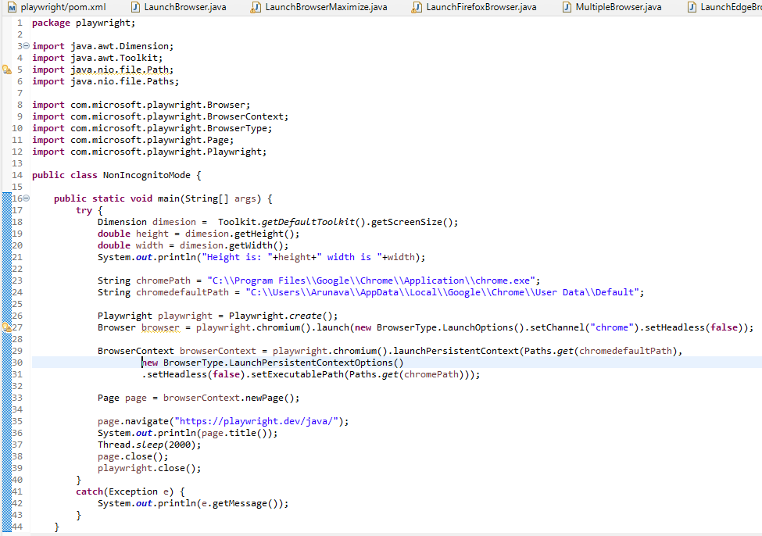
We can now see all the history and browser is not launched in incognito mode.

Playwright Navigation methods:
Here we will see how to navigate to a web page, go back, go forward and reload.
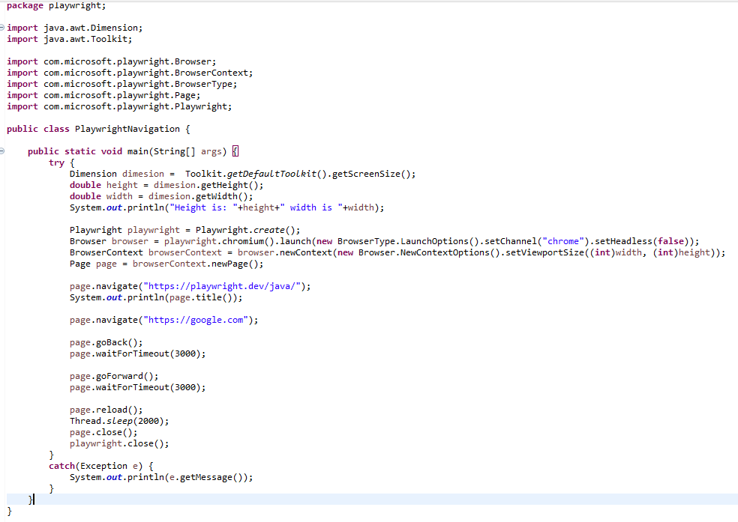
We can also add timeout to explicitly instruct the automation script on how much time it should wait for the go back and go forward operation.
